Udemy Url = [Notebook](https://notebook.zohopublic.in/public/notes/dcr5ze84495de6ad14cadbf5fe38b99b18b9d)

If no profiling is set than by default the application.properties will get picks up.

* If we add spring.profiles.active=xxx then, spring will pick application.properties and then it reads spring.profiles and set that profile.
* If we run the application using mvn spring-bootrun -Dspring-boot.run.profile=prod
* Then prod will get picks up and it will override the spring.profiles.

In industry the widely used way to apply profiling is use pom.xml - <profiles> -P**production**

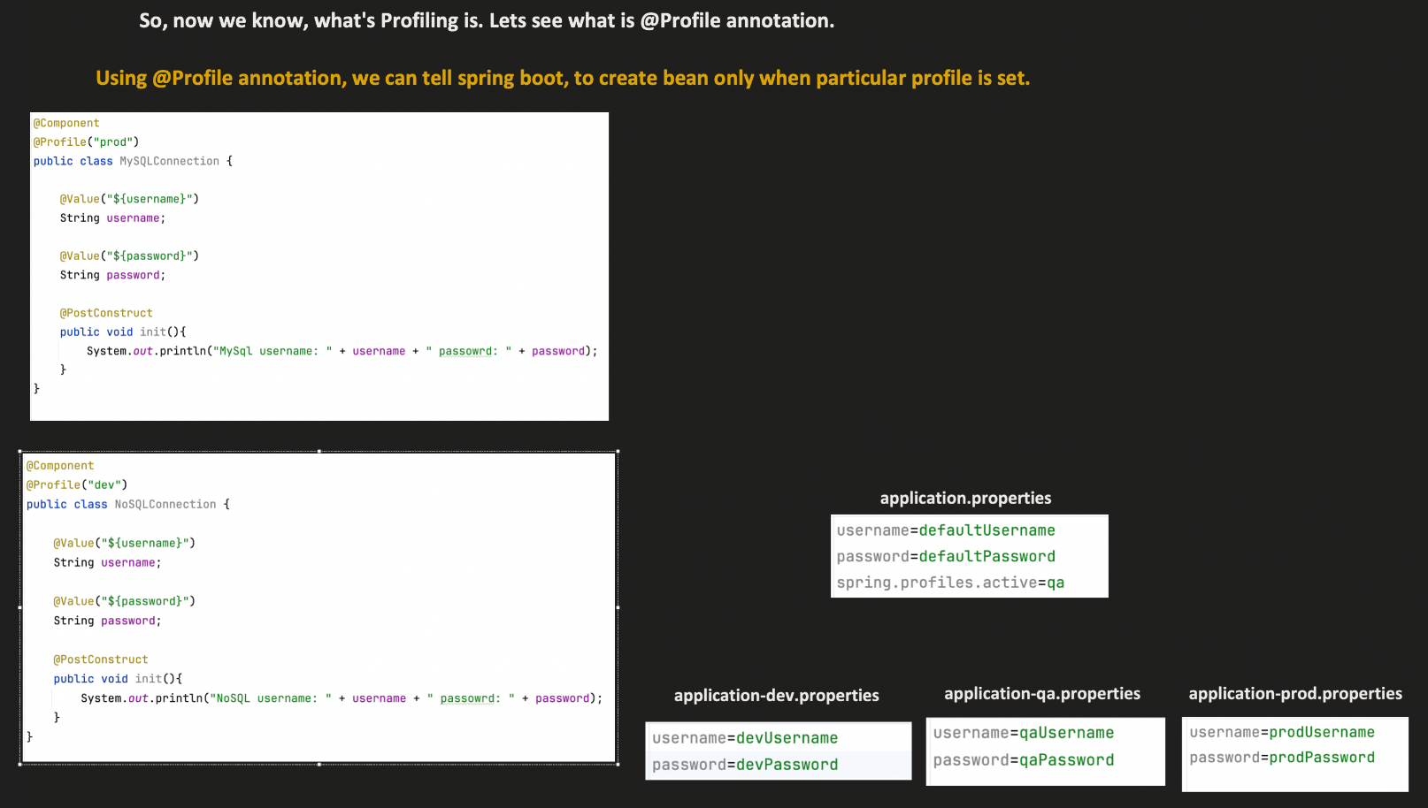

If we set multiple profiles then the last one will get picks up. For example – below we passed prod, qa. But if we notice logs for both prod and qa the bean gets created but with qa’s username and password.

Even though we can achieve this profiling but it is recommended to use @ConditionalOnProperty because it brakes the meaning of profiling. Profiling was created to create the bean specific to environments not on the conditions.